Homework 6

**Question 13.2**

In this problem you, can simulate a simplified airport security system at a busy airport. Passengers arrive according to a Poisson distribution with λ1 = 5 per minute (i.e., mean inter-arrival rate µ1 = 0.2 minutes) to the ID/boarding-pass check queue, where there are several servers who each have exponential service time with mean rate µ2 = 0.75 minutes. [Hint: model them as one block that has more than one resource.] After that, the passengers are assigned to the shortest of the several personal-check queues, where they go through the personal scanner (time is uniformly distributed between 0.5 minutes and 1 minute).

Answer:

I used Arena to solve this problem. The report generated by Arena was attached. Below are the screen shot of my setup:

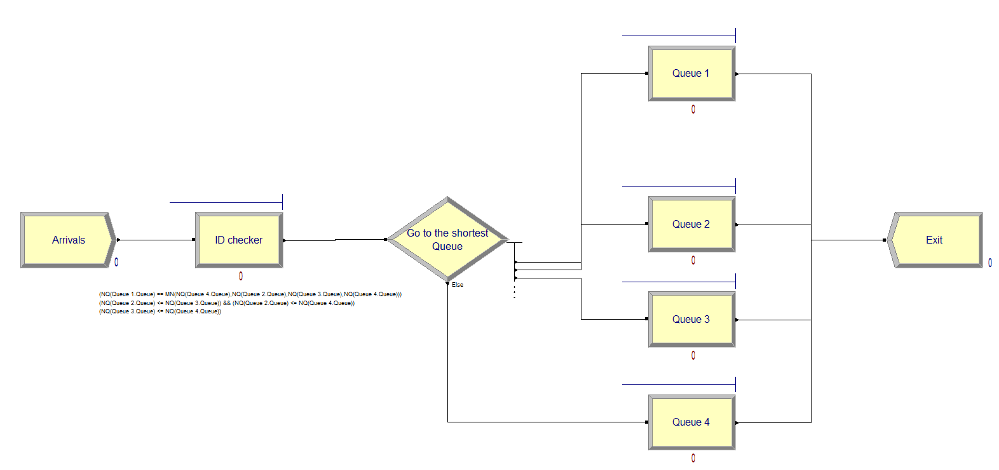

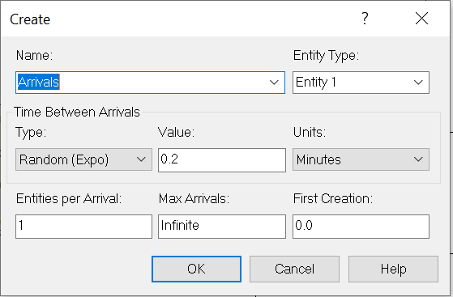 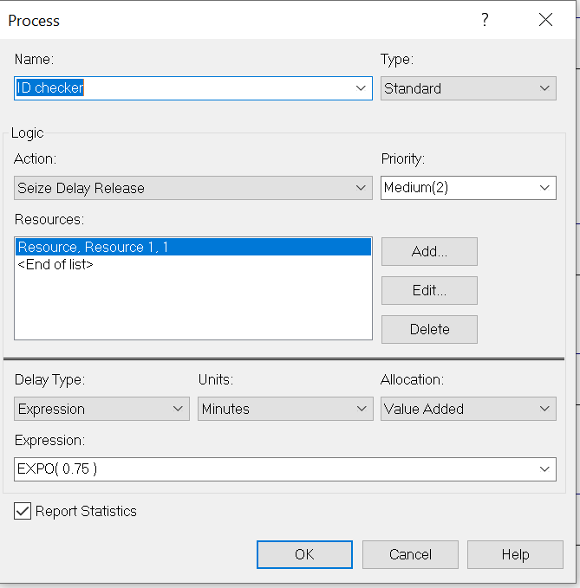

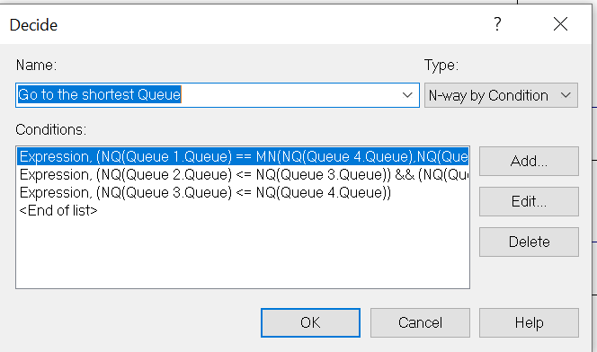

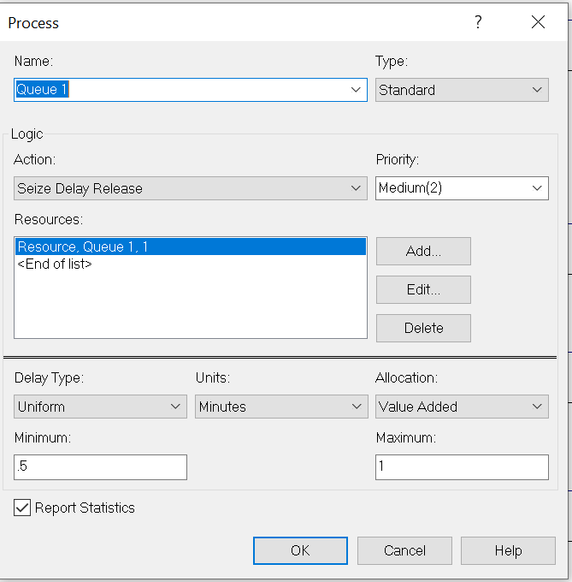

The key of this assignment is to find the right capacity of the resource in the ID Checker, and the right number of queues after the ID check. My solution is to set capacity to 4, and added 4 queues to the program.

**Question 14.1**

The breast cancer data set breast-cancer-wisconsin.data.txt has missing values.

1. Use the mean/mode imputation method to impute values for the missing data.

2. Use regression to impute values for the missing data.

3. Use regression with perturbation to impute values for the missing data.

4. (Optional) Compare the results and quality of classification models (e.g., SVM, KNN) build using

(1) the data sets from questions 1,2,3;

(2) the data that remains after data points with missing values are removed; and

(3) the data set when a binary variable is introduced to indicate missing values.

library(nnet)  
library(MASS)  
library(kknn)  
cancer<- read.table("http://archive.ics.uci.edu/ml/machine-learning-databases/breast-cancer-wisconsin/breast-cancer-wisconsin.data",sep = ",", stringsAsFactors = FALSE, header=F)  
head(cancer)

## V1 V2 V3 V4 V5 V6 V7 V8 V9 V10 V11  
## 1 1000025 5 1 1 1 2 1 3 1 1 2  
## 2 1002945 5 4 4 5 7 10 3 2 1 2  
## 3 1015425 3 1 1 1 2 2 3 1 1 2  
## 4 1016277 6 8 8 1 3 4 3 7 1 2  
## 5 1017023 4 1 1 3 2 1 3 1 1 2  
## 6 1017122 8 10 10 8 7 10 9 7 1 4

# check for the missings

str(cancer)

## 'data.frame': 699 obs. of 11 variables:  
## $ V1 : int 1000025 1002945 1015425 1016277 1017023 1017122 1018099 1018561 1033078 1033078 ...  
## $ V2 : int 5 5 3 6 4 8 1 2 2 4 ...  
## $ V3 : int 1 4 1 8 1 10 1 1 1 2 ...  
## $ V4 : int 1 4 1 8 1 10 1 2 1 1 ...  
## $ V5 : int 1 5 1 1 3 8 1 1 1 1 ...  
## $ V6 : int 2 7 2 3 2 7 2 2 2 2 ...  
## $ V7 : chr "1" "10" "2" "4" ...  
## $ V8 : int 3 3 3 3 3 9 3 3 1 2 ...  
## $ V9 : int 1 2 1 7 1 7 1 1 1 1 ...  
## $ V10: int 1 1 1 1 1 1 1 1 5 1 ...  
## $ V11: int 2 2 2 2 2 4 2 2 2 2 ...

# We noticed that V1-V11 are all integer values, except V7. I will take a closer look at V7.

**table**(cancer$V7)

? 1 10 2 3 4 5 6 7 8 9

16 402 132 30 28 19 30 4 8 21 9

# V7 has missing value, which was marked as “?”. Now check how many data are missing in V7.

mis<-subset(cancer,cancer$V7=="?")  
nrow(mis)

## [1] 16

# 16 obs were missing, which account for 16/699=2.29% of the total data. We can go ahead and impute values for the missings.

# 1. Use the mean/mode imputation method to impute values for the missing data.

# Find the mode value

v1<-nrow(subset(cancer,cancer$V7==1))  
v2<-nrow(subset(cancer,cancer$V7==2))  
v3<-nrow(subset(cancer,cancer$V7==3))  
v4<-nrow(subset(cancer,cancer$V7==4))  
v5<-nrow(subset(cancer,cancer$V7==5))  
v6<-nrow(subset(cancer,cancer$V7==6))  
v7<-nrow(subset(cancer,cancer$V7==7))  
v8<-nrow(subset(cancer,cancer$V7==8))  
v9<-nrow(subset(cancer,cancer$V7==9))  
v10<-nrow(subset(cancer,cancer$V7==10))  
v<-c( v1 , v2 , v3 , v4 , v5 , v6 , v7 , v8 , v9 , v10 )  
  
mode<-which.max(v)  
mode

## [1] 1

# 1 is the mode

# Assign mode value to the missings

cancer1<-cancer  
cancer1$V7[cancer1$V7=="?"]<-mode  
sum(cancer1$V7=="?")#We have sucessfully changed "?" to 1

## [1] 0

cancer1$V7<-as.integer(cancer1$V7)  
str(cancer1$V7)

## int [1:699] 1 10 2 4 1 10 10 1 1 1 ...

# 2. Use regression to impute values for the missing data.

# Leave out the response variables and V1 which is ID, and use stepwise method to predict the V7 with all the other variables

cancer2<-cancer[cancer$V7!="?",2:10]  
cancer2$V7 <- as.integer(cancer2$V7)

# 70% for training

mask_train<-sample(nrow(cancer2), size = floor(nrow(cancer2) * 0.7))

# training data set

train<-cancer2[mask_train,]

# Using the remaining data for test

test<-cancer2[-mask_train, ] # all rows except training

# Fit the model

reg<- multinom(V7 ~ ., data = train)

## # weights: 100 (81 variable)  
## initial value 1100.635674   
## iter 10 value 738.506697  
## iter 20 value 546.160554  
## iter 30 value 479.243308  
## iter 40 value 432.340956  
## iter 50 value 424.368253  
## iter 60 value 423.160896  
## iter 70 value 422.578859  
## iter 80 value 422.074623  
## iter 90 value 421.298496  
## iter 100 value 420.270150  
## final value 420.270150   
## stopped after 100 iterations

summary(reg)

## Call:  
## multinom(formula = V7 ~ ., data = train)  
##   
## Coefficients:  
## (Intercept) V2 V3 V4 V5 V6  
## 2 -4.717949 0.15570995 0.12979546 -0.30938051 -0.04399826 0.05644216  
## 3 -3.800999 -0.03723532 0.21116166 0.05390461 0.21550949 -0.05180473  
## 4 -5.753214 0.21279724 0.37648965 0.02305562 -0.05610244 -0.12010129  
## 5 -4.944981 0.18300893 -0.03782338 0.27806962 0.26608868 0.05526566  
## 6 -24.646647 -1.64196772 1.02195343 3.75165874 -1.81272892 -4.18796189  
## 7 -8.215568 0.63027705 -0.75256975 0.72682523 0.32657153 -0.92634166  
## 8 -7.309866 0.05760286 0.06672619 0.32941415 0.30333228 0.34938933  
## 9 -7.060588 -0.10358529 0.12739754 0.27452567 -0.02637578 -0.33538970  
## 10 -6.454512 0.31794210 -0.09753105 0.31544033 0.40304005 0.11732450  
## V8 V9 V10  
## 2 0.41234919 0.048187886 0.40044583  
## 3 -0.01566152 0.077776199 0.27493870  
## 4 0.11368783 0.149248626 0.12758427  
## 5 0.14886235 0.136433546 -0.62391550  
## 6 -7.58742416 3.527511651 3.83488941  
## 7 0.15229462 0.370226768 0.22533082  
## 8 0.25222710 -0.007207503 -0.37493148  
## 9 0.44430271 0.211937012 0.53460981  
## 10 0.30522100 0.012094298 0.07435297  
##   
## Std. Errors:  
## (Intercept) V2 V3 V4 V5 V6  
## 2 0.6055716 0.11705757 0.2051448 0.2145342 0.16917444 0.1931160  
## 3 0.5790774 0.11598304 0.1920415 0.1910212 0.12829261 0.1973117  
## 4 0.9164978 0.15165487 0.2078790 0.2036061 0.18925469 0.2208576  
## 5 0.7776761 0.11516890 0.1957008 0.2069221 0.12151056 0.1704099  
## 6 16.5881518 11.53426761 9.8912871 21.1457943 32.39631601 13.2292612  
## 7 2.2080246 0.27591292 0.4714759 0.4266245 0.21225069 0.6549271  
## 8 1.0864427 0.13921935 0.2154042 0.2247189 0.13152735 0.1712012  
## 9 1.4563364 0.23652054 0.3367735 0.3410405 0.24003063 0.3755600  
## 10 0.6161176 0.08704563 0.1469826 0.1519413 0.09454802 0.1287049  
## V8 V9 V10  
## 2 0.1596219 0.13066645 0.1631515  
## 3 0.1710745 0.12445152 0.1682904  
## 4 0.1904857 0.12947967 0.2313830  
## 5 0.1566109 0.11040643 0.4188275  
## 6 28.5317700 11.00520741 7.5821159  
## 7 0.3002198 0.23097065 0.2869629  
## 8 0.1718295 0.11825923 0.3041753  
## 9 0.2768113 0.21178338 0.2254439  
## 10 0.1175911 0.08551794 0.1546946  
##   
## Residual Deviance: 840.5403   
## AIC: 1002.54

# 

# Use stepwise method to re-fit the model with all the predictors

stp<-stepAIC(reg, direction="both")

stp$anova

## Stepwise Model Path   
## Analysis of Deviance Table  
##   
## Initial Model:  
## V7 ~ V2 + V3 + V4 + V5 + V6 + V8 + V9 + V10  
##   
## Final Model:  
## V7 ~ V2 + V4 + V5 + V10  
##   
##   
## Step Df Deviance Resid. Df Resid. Dev AIC  
## 1 397 840.5403 1002.5403  
## 2 - V9 9 6.562125 406 847.1024 991.1024  
## 3 - V6 9 10.261035 415 857.3635 983.3635  
## 4 - V8 9 14.064150 424 871.4276 979.4276  
## 5 - V3 9 15.657716 433 887.0853 977.0853

summary(stp)

## Call:  
## multinom(formula = V7 ~ V2 + V4 + V5 + V10, data = train)  
##   
## Coefficients:  
## (Intercept) V2 V4 V5 V10  
## 2 -4.244079 0.233314972 -0.01831701 0.09842886 0.4461068  
## 3 -3.977251 -0.002954217 0.23971446 0.26597426 0.2680801  
## 4 -5.984342 0.311416141 0.39004871 0.07554026 0.1362541  
## 5 -4.784467 0.200656304 0.40964542 0.32030620 -0.5156343  
## 6 -174.618945 -26.217078440 51.51823310 -138.74236122 24.7517131  
## 7 -8.738836 0.568360901 0.22925155 0.21899372 0.2849337  
## 8 -6.659441 0.142579032 0.63234144 0.36065952 -0.2551220  
## 9 -6.861861 0.006896686 0.52630341 0.09042632 0.5020227  
## 10 -6.004218 0.346808200 0.42398836 0.46102001 0.1049665  
##   
## Std. Errors:  
## (Intercept) V2 V4 V5 V10  
## 2 0.4985172 0.11167151 0.15751771 0.14376253 0.1480218  
## 3 0.4758144 0.11000987 0.12846841 0.11967032 0.1655908  
## 4 0.7961750 0.13979062 0.14234663 0.16011529 0.2147479  
## 5 0.6899172 0.10958731 0.12103548 0.11680544 0.3917847  
## 6 2.3055036 20.49769251 22.95502299 2.30818043 2.5236261  
## 7 1.6504876 0.22498564 0.20329670 0.18762045 0.2174785  
## 8 0.9550593 0.12773761 0.13886534 0.12713083 0.2792393  
## 9 1.1871724 0.20899273 0.20195468 0.21076758 0.2147189  
## 10 0.5434100 0.08321057 0.09448628 0.09089512 0.1463541  
##   
## Residual Deviance: 887.0853   
## AIC: 977.0853

# Generate the model from stepwise method

model<- lm(V7~V2+V4+V5+V8, cancer2)  
summary(model)

##   
## Call:  
## lm(formula = V7 ~ V2 + V4 + V5 + V8, data = cancer2)  
##   
## Residuals:  
## Min 1Q Median 3Q Max   
## -9.8115 -0.9531 -0.3111 0.6678 8.6889   
##   
## Coefficients:  
## Estimate Std. Error t value Pr(>|t|)   
## (Intercept) -0.53601 0.17514 -3.060 0.0023 **   
## V2 0.22617 0.04121 5.488 5.75e-08 ***  
## V4 0.31729 0.05086 6.239 7.76e-10 ***  
## V5 0.33227 0.04431 7.499 2.03e-13 ***  
## V8 0.32378 0.05606 5.775 1.17e-08 ***  
## ---  
## Signif. codes: 0 '***' 0.001 '**' 0.01 '*' 0.05 '.' 0.1 ' ' 1  
##   
## Residual standard error: 2.274 on 678 degrees of freedom  
## Multiple R-squared: 0.6129, Adjusted R-squared: 0.6107   
## F-statistic: 268.4 on 4 and 678 DF, p-value: < 2.2e-16

# Use test dataset to validate

pred<-round(predict(model,test))  
acc<-sum(pred == test$V7) / nrow(test)  
acc

## [1] 0.3268293

# 0.356 accuracy rate is not good.But this is the only model we got, so I will go ahead and use this model to impute the missings

# Get the subset of the data with the missings, and the subset with all the valid data points

mis2<-subset(cancer,V7=="?")  
ok<-subset(cancer,V7!="?")

# Assign the imputed values to V7

mis2$V7<-round(predict(model,mis2))

# Put these data back to the cancer dataset

cancer2final<-rbind(ok,mis2)  
cancer2final$V7<-as.integer(cancer2final$V7)

# make the values outside of the orignal range back to [1,10]

cancer2final$V7[cancer2final$V7 > 10] <- 10  
cancer2final$V7[cancer2final$V7 < 1] <- 1

# 3. Use regression with perturbation to impute values for the missing data.

set.seed(123)  
  
v7<-round(predict(model,mis2))  
  
mis3<-subset(cancer,V7=="?")  
  
v7new<-round(rnorm(nrow(mis3),v7,sd(v7)))

# make the values outside of the orignal range back to [1,10]

mis3$V7<-v7new  
  
mis3$V7[mis3$V7 > 10] <- 10  
mis3$V7[mis3$V7 < 1] <- 1  
  
cancer3<-rbind(ok,mis3)  
cancer3$V7<-as.integer(cancer3$V7)

# 4.Compare the results and quality of classification models (e.g., SVM, KNN) build using

# (1) the data sets from questions 1,2,3;

# 70% for training

mask_train1<-sample(nrow(cancer1), size = floor(nrow(cancer1) * 0.7))

# 4.1.1, with mode imputation

acc<-rep(0,25)

# training data set

train1<-cancer1[mask_train1,]

# Using the remaining data for test

test1<-cancer1[-mask_train1, ]   
  
for (k in 1:5){  
knn4.1.1 <- kknn(V11~V2+V3+ V4+ V5+ V6+ V7+ V8+ V9+ V10,train1,test1,k=k)  
pred1 <- as.integer(fitted(knn4.1.1)+0.5)  
acc[k]<-sum(pred1 == test1$V11) / nrow(test1)  
}

# 4.1.2, with regression imputation

train2<-cancer2final[mask_train1,]   
test2<-cancer2final[-mask_train1, ]   
  
for (k in 1:5){  
 knn4.1.2 <- kknn(V11~V2+V3+ V4+ V5+ V6+ V7+ V8+ V9+ V10,train2,test2,k=k)  
 pred2 <- as.integer(fitted(knn4.1.2)+0.5)  
 acc[k+5]<-sum(pred2 == test2$V11) / nrow(test2)  
}

# 4.1.3, with regression imputation

train3<-cancer3[mask_train1,]   
test3<-cancer3[-mask_train1, ]   
  
for (k in 1:5){  
 knn4.1.3 <- kknn(V11~V2+V3+ V4+ V5+ V6+ V7+ V8+ V9+ V10,train3,test3,k=k)  
 pred3<- as.integer(fitted(knn4.1.3)+0.5)  
 acc[k+10]<-sum(pred3 == test3$V11) / nrow(test3)  
}

# 4.2, the data that remains after data points with missing values are removed;

cancer4<-subset(cancer,V7!="?")  
cancer4$V7<-as.integer(cancer4$V7)  
train4<-cancer4[mask_train1,]   
test4<-cancer4[-mask_train1, ]   
  
for (k in 1:5){  
 knn4.2 <- kknn(V11~V2+V3+ V4+ V5+ V6+ V7+ V8+ V9+ V10,train4,test4,k=k)  
 pred4<- as.integer(fitted(knn4.2)+0.5)  
 acc[k+15]<-sum(pred4 == test4$V11) / nrow(test4)  
}

# 4.3, the data set when a binary variable is introduced to indicate missing values

# Add a binary variable to the original data to indicate if V7 is missing or not. 0=missing,1= not missing

cancer5 <- cancer  
cancer5$V12[cancer5$V7 == "?"] <- 0  
cancer5$V12[cancer5$V7 != "?"] <- 1

# Create interaction factor for V7 and V12.

cancer5$V13[cancer5$V7 == "?"] <- 0  
cancer5$V13[cancer5$V7 != "?"] <- as.integer(ok$V7)  
  
train5<-cancer5[mask_train1,]   
test5<-cancer5[-mask_train1, ]

# Use the interaction factor in the modeling.

for (k in 1:5){  
 knn4.3 <- kknn(V11~V2+V3+ V4+ V5+ V6+ V8+ V9+ V10+V13,train5,test5,k=k)  
 pred5<- as.integer(fitted(knn4.3)+0.5)  
 acc[k+20]<-sum(pred5 == test5$V11) / nrow(test5)  
}  
  
acc

## [1] 0.9476190 0.9476190 0.9190476 0.9190476 0.9190476 0.9333333 0.9333333  
## [8] 0.9095238 0.9095238 0.9095238 0.9333333 0.9333333 0.9095238 0.9095238  
## [15] 0.9095238 0.9514563 0.9514563 0.9320388 0.9320388 0.9320388 0.9476190  
## [22] 0.9476190 0.9190476 0.9190476 0.9190476

plot(acc)

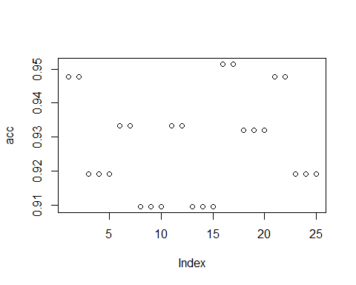

which.max(acc)

## [1] 16

# There isn’t much differences between the differenct methods to deal with the missing data (the accuracy rate are all withn 90%-95%).

# However, removing the missing values, generated a slightly higher predictive accuracy at k=1, for the knn model.

Question 15.1

Describe a situation or problem from your job, everyday life, current events, etc., for which optimization would be appropriate. What data would you need?

Answer:

# Graduate students may want to decide which courses to choose in each semester, in order to maximize the GPA when graduating.

# Data needed:

# Workload of each courses and the time needed per week

# Personal schedules and estimated time that can be used for study

# Study plan that indicates which courses must be taken (based on school requirements, personal interests, and career goals)

# The order of the coursers (take introduction courses before the ones that require deeper understanding)

# Total credits taken each semester should meet school requirements

# The amount paid should be within the education budget